Potential Enemies Project Sanguine Soul
Elliott Bailey-Wills

Shielded
Description
This enemy is 100% shielded at its front and therefore cannot be damaged by a frontal attack. This character stands at 195 cm tall with a shield that also stands at the same height of 195 cm. When rotating its body to face the player on its shielded side it will rotate a full 90 degrees in 3 seconds. The enemy has a weak point on the back of its head and will replenish the player 10 AP on a successful hit. This enemy has 125 HP when hit on any part of the body that is not shielded by a basic attack this will do 25 damage. When hit by a Dash Strike or Shield Bash on any unshielded part of the body this unit will take 75 damage. The behavior of this enemy will be further explained in states, but its main goal is to protect enemy units.
This enemy type has three states in which it can be in, however cannot exist in two states at the same time.
- Idle
- While inside the idle state the enemy is actively patrolling within a set square grid that is 300x300 cm. In most cases it is patrolling around another enemy type.

- Attack
- This enemy is usually reliant on other enemies to spot the player and if spotted by another enemy unit it will go into this state. However, it can spot the player character at a distance of 500 cm without line of sight obstructions. When attack is triggered it move towards until it is 300 cm away from the player character at a rate of 10 meters per second then stops moving. It will not move again until another state is triggered but will rotate to keep its shield in front of the player at all times. It will then start throwing small projectiles that explode with an AOE burst that extends 45cm out in all directions also causing a small fire. The initial blast will cause 10 damage if the player is not out of the AOE’s area within 1 second of the explosion or enters that area for the next 5 seconds the player will take 5 damage per second for 3 seconds until leaving the area or the area dissipates. This attack has a 2.5 second cooldown.
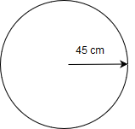
Block
- When a retreat function is called by another enemy unit, the shielded unit will stop attacking and charge the player at a rate of 7 meters per second in a straight line towards the players last position when this state was triggered in an attempt to shield retreating allies from damage, if the player is hit by the shield the player takes 10 damage and is knocked backwards 50cm. After reaching the players last position it will face the player and retreat to 150 cm away staying in front of the player. It will always attempt to stay 150cm in front of the player until the retreating unit has reentered the attack state in which it will also reenter the attack state and back up to a distance of 300 cm away.
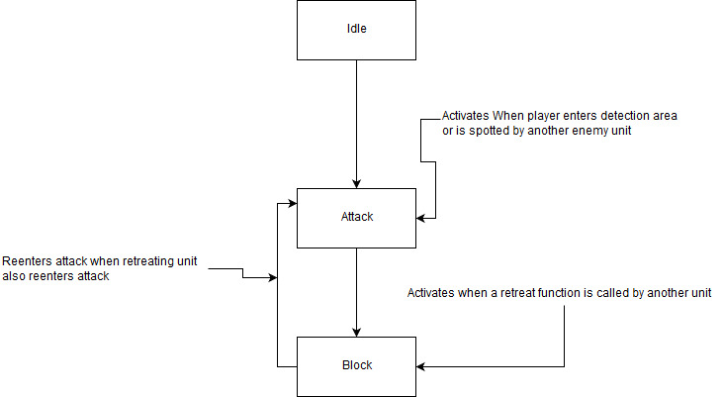

Sniper
Description
The sniper is a long-range attacker that actively hunts the player until defeated. This unit stands at 183cm tall. This unit has a weak point on its chest that if hit grants the player 10 AP. This unit’s hp is 75 HP when hit with a basic attack on any part of the body it takes 25 damage. When it is hit by a Dash Strike or Shield Bash it take 75 damage. Usually this unit is in a high to reach place or behind other units making it difficult to attack.
This enemy type has two states in which it can be in, however cannot be in two states at the same time.
- Idle
- While in this state the enemy does not move but is actively searching by turning it head thus moving its cone of detection.

- Attack
- This enemy can spot the player at a distance of 5000 cm with no line of sight obstruction and the player is within its cone of vision which will be shown by a green cone however when the player is spotted it does not alert other enemy types. When the player is spotted it cannot reenter the Idle state and will actively track the player attempting to be no more than 2000 cm away form the player. When attacking the player the enemy will stop moving and the player will hear a charging noise and a small blue beam will track the player. After 3 seconds the beam will stop and the enemy will attack if the player is hit it will cause 30 damage and will burn the player for 3 seconds doing 5 damage per second. Causing a total of 45 damage. This attack cannot penetrate through obstacles and has a range of 5000cm. If the player uses a healing item, the burn damage will stop. This attack has a 6 second cooldown.
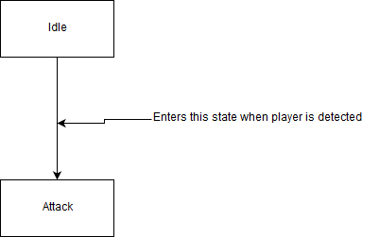
Berserker
Description
The Berserker is a close range combat unit and stands at 265cm tall. This unit has a weak points on its left and right shoulders on a successful hit of this weak point the player is has 10 AP replenished. This unit has 200 HP when hit with a basic attack this unit loses 25 HP. When hit with a Sheild Bash or Dash Strike will lose 75 HP. This unit does become more dangerous when weakened.
This enemy type has three states in which it can be in, however cannot exist in two states at the same time.
- Idle
- This unit does not move and does not look for the player.

- Attack
- This unit will start attacking only after the player has attacked any unit within 1000cm of the berserker or has damaged the berserker itself. This also alerts other enemies to player’s position if action occurred with their detection radius. When this state is triggered it will immediately rush the player at a rate of 12 meters a second and then will start attacking the player with its fists when it is 30 cm away from the player. This will cause 20 damage to the player every 3 seconds.

- Rage
- When the player has lowered a berserker’s health halfway it will enter this state for 5 seconds or until defeated. When in this state the berserker’s movement speed and attack speed are doubled. Causing it to move at a rate of 8 meters a second and cause 20 damage to the player every 1.5 seconds. However, in this state it will also damage other enemy units within 30 cm of it as well if it is attacking the player.
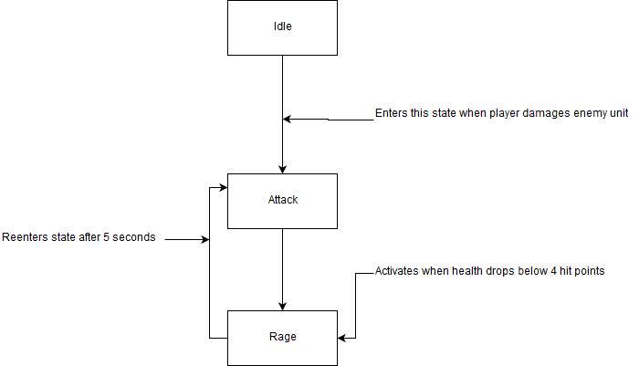

BONUS
Potential Weapons
Hell’s Bow
This weapon can be found if the player explores their surroundings. This weapon causes 1 damage to enemies and heals the player 50 hp over a 3 sec time period, but taking damage will lessen the amount healed. For example, if an enemy is shot the player gains 50 hp but if the player takes 20 hp of damage the player will only recover 30 hp. This weapon effect has a 5 second cooldown.
Heaven’s Sword
This weapon can be found if the player explores their surroundings. This weapon causes 1 damage to enemies and replenishes 50 ap over a 3 sec time period but taking damage will lessen the amount replenished by the amount of damage taken. For example, if an enemy is hit the player gains 50 ap but if the player takes 20 hp of damage the player will only recover 30 ap. This weapon effect has a 5 second cooldown.

