Sanguine Soul
Game Design Document
Dead Level
Version 1.6

Producer | Mitchelson Brooks
Creative Director | Louis McTague
Art Lead | Tony Cuni
Tech Lead | Emilio Alban
Artist | Mary Ellis
Artist | Nicolas Witthoeft
Artist | Carly Hasson
Artist | Daniel Dabdoub
Programmer | Dylan Rodrigues
Programmer | Kaelee Feliciano
Designer | Joe Colombo
Designer | Elliott Bailey-Wills
Designer | Edwin Sanchez
Designer | Ryun Wheat

Document Revision Table

Version | Updates | Advocate | Date
1.0 | Initial Document | Louis McTague, Edwin Sanchez | 9/20/2018
1.1 | Ability and Enemy Additions | Louis McTague | 10/2/2018
1.2 | Formatting, Added Level Graphs, Update UI images | Louis McTague | 10/4/2018
1.3 | Improved Level Graphs, UI images, Wording, Formatting | Louis McTague, Mitchelson Brooks | 10/5/2018
1.4 | Update Content to Reflect Current Scope | Louis McTague | 11/7/2018
1.5 | Refine Content | Mitchelson Brooks | 11/9/2018
1.6 | Update Level Graphs | Louis McTague | 11/9/2018

Table of Contents
Concept 1
Story: 1
Gameplay: 1
Mechanics: 2
Systems 4
Items 4
Enemies 4
Controls: 6
Interface: 6
Environment: 9

Concept

High Concept:

Combat using supernatural abilities to dominate enemies leads to a sense of excitement and empowerment. Exploration of a rich middle-eastern inspired environment leads to a sense of wonder and satisfaction.

Game Goals:
Create a world for players that rewards exploration with a compelling narrative. Develop engaging combat that encourages thinking ahead, flexibility, and quick reactions.

Features:
- Levels reward exploration through discoverable lore
- Fast-paced, shooter combat
- Engaging, difficult enemies with exploitable weak points
- Fun, powerful abilities
- Combat playgrounds

Story:

Story Synopsis:
Malieun is a powerful warlock-king who has ruled his domain for many years. Betrayed by his people, Malieun suffers a seemingly mortal blow by a wandering wizard named Noor. However, Malieun discovers a newfound power on the brink of death that enables him to convert his magic power into life force or his life force into magic power. Using what’s left of his magic, he staves off death. Equipped with this new-found ability, Malieun must defeat all that stands in his way to get revenge on Noor who cursed him.

Characters:
Player Character - Maleun - Objectively Evil: Considered to be an immoral character of the story. Malieun’s features such as age and appearance are left ambiguous.
Noor - Objectively Good: After years of torment, the townspeople prayed for a hero to save them from Malieun’s rule. Noor was the answer to their prayers. Noor, having seen the result of Malieun’s evil decides to attempt to stop him once and for all. Noor is a middle eastern woman around 30 years of age.

Gameplay:

Overview:
Players use a variety of abilities to engage in combat with enemies. High movement speed and quick, aggressive abilities result in fast-paced combat. Each ability drains from the limited Ability Power (AP) pool which is regained by hitting enemies in weak points or by transferring Health Points (HP) into AP. Additionally, the player can transfer their AP into HP. Outside of combat, players explore to increase their resources for the next fight.
For the purposes of this document, one centimeter is equal to one Unreal Unit.

Mechanics:

Player Character Attributes:
The player character is 192 cm tall and 110 cm wide. The player has separate HP and AP values that draw from the same resource pool.
- Health Points - The player starts the first level with 100 HP and subsequent levels with the HP remaining from the prior level. If the player’s HP is ever 0, the player dies.
- Death - Death results in the player’s screen fading out over .5 seconds. After another 1 seconds of waiting, the player respawns at their most recent checkpoint (see Checkpoints), fading in over .5 seconds.
- Receiving Damage - Colliding with enemy attacks results in the player receiving damage. Whenever the player receives damage, the camera shakes for .25 seconds, after which the camera returns to wherever the player is aiming.
- Ability Power - The player starts the fist level with 100 AP and subsequent levels with the AP remaining from the prior level. All player abilities drain the player’s AP by varying amounts.

Camera:
A first-person camera is attached to the player character at a height of 160 centimeters. Horizontal input results in rotation of the player in the direction of input while vertical input tilts the camera in the direction of input. The camera’s tilt cannot exceed 90 degrees or be less than -90 degrees. For the purposes of this document the center of the camera’s view shall be considered where the player is aiming.
Grounded:
The player’s grounded state can be true or false. This state is used to calculate when the player is airborne. Grounded is true if a ray cast that originates at the center of the player character and ends 1 meter in the negative Z-vector hits a mesh.

Movement:
- Running - The player uses the movement axis to move forward, backward, left, and right relative to where the player is aiming. Regardless of where the player is aiming only movement in the X and Y dimensions is translated. When moving, the player accelerates over .5 seconds up to a max speed of 7 meters per second. When the player stops inputting a direction, the character accelerates to a complete stop over .25 seconds.
- Jumping - To jump, the player must be in the Grounded state. The player jumps in an upwards direction along the Z axis. Jumping reaches an apex of 1 meters high over .5 seconds. Upon reaching the apex of the jump, gravity brings the player back down towards the ground at a rate of -9.8 meters per second. Jumping has a cooldown of .2 seconds immediately after landing.

Transferring
The player transfers either of their resources into the other at a rate of 50 points per second while the appropriate input is held down. When the input is no longer held, the transferring immediately stops and cannot be used again for .25 seconds. Transfers cannot be used simultaneously.
- HP to AP - HP cannot go lower than the value of 1 through transferring. While transferring, the player receives a movement speed boost of 25%.
- AP to HP - While transferring, the player receives a movement speed boost of 25%.

Abilities
The player begins the game with the Basic Attack ability and Dash Strike Ability. The player also finds upgrades for their abilities within levels. Upgrades are not essential to progression.
- Basic Attack - Projectiles spawn on input press. Every fired projectile drains 2 AP. If a projectile collides with an enemy, the enemy loses 25 from their HP. Fired projectiles spawn 1 meter in front of the player, travel forward in the direction of the players aim at a rate of 20 meters a second. If the Basic Attack projectile collides with another projectile, then both are destroyed. Projectiles destroy whenever they collide with non-player or non-projectile objects or after 5 seconds of spawning.
- Basic Attack Upgrade: Remote Detonation – Activates on input release, draining 50 AP. Instantly disables player input. All Basic Attack projectiles in the game space stop moving. After .25 seconds all Basic Attack projectiles detonate and deal 75 damage to all enemies within a 2 meter radius. Afterwards player input is reenabled.
- Dash Strike - Activates on input press, draining 20 AP. Activating Dash Strike instantly disables player input, attempts to move the player to a position that is 10 meters along their forward vector. The player dashes at a constant speed until the player reaches max distance or collides with a surface and is unaffected by gravity. Then input is reenabled.
At the end of the dash the player strikes the ground and deals 75 damage to all enemies within a 3 meter radius originating at the player’s end position. During the entirety of the Dash Strike, the player is unable to be damaged by enemies. Afterwards player input is reenabled.
- Dash Strike Upgrade: Shield Strike – On input hold, generates a shield in front of the player that absorbs projectiles. The shield lasts for up to 2 seconds, at which point it fizzles, no longer absorbing projectiles. The shield is 225 centimeters tall by 1 meter wide, with the last 25 centimeters of each side curving inwards by 15 degrees. This shield moves with the player, staying in front of them. While the shield is up, the player’s turn speed and movement speed are reduced to 25% of their original value.
If input is released before the shield fizzles then the player dashes forward using Dash Strike functionality.
If the player collides with an enemy they are knocked back 3 meters in the direction of the player dash.

Systems

Items
Items apply an effect to the player when the player collides with them.
- Health - Adds 25 health to the player’s resource pool. If the players pool fills beyond 200 total resources, it is filled to 200 instead.
- Ability Power - Adds 25 player to the player’s resource pool. If the players pool fills beyond 200 total resources, it is filled to 200 instead.
- Key – Keys are used to unlock doors. Keys are different colors, that match the colors of door locks and torches in the environment. These doors are locked for the player until the player picks up the correspondingly colored key. Once obtained, all doors that match the obtained key unlock within 10 meters of the door.
- Documents - Narrative documents are found in levels and contain pieces of background lore which can be read once picked up. Once picked up, the player may press the appropriate input within 3 seconds to read the document. Additionally, documents are contained within the player’s Document Menu for potential visitation and rereading.
Checkpoints
Checkpoints are boxes that are invisible to the player and can be sized in any way. Checkpoints are located at the starting location of every level, with more being placed around levels. The player respawns at the most recent checkpoint area if they die. Entering a checkpoint makes it the most recent checkpoint. Players respawn with 50 HP and 50 AP.

Spawners
Spawners create instances of predetermined enemy types at predetermined locations once the player collides with a spawner. This box is invisible to the player and can be resized. There are three variations of enemy spawners:
- Single-Use Spawners – Instantiates enemies the first time the player enters.
- Timed Spawners - Instantiates enemies and begins a customizable timer that upon finishing resets the spawner so that it will spawn enemies the next time the player enters it.
- Wall Spawners – This spawner creates predetermined temporary walls, as well as enemies. These walls are destroyed once all spawned enemies are defeated.

Enemies
Enemies have a number of states but can only be in one state at a time. Each enemy has their own HP. When an enemy’s HP reaches 0 or lower, that enemy is killed and disappears from the game. When an enemy receives damage, the enemy flashes red for .1 seconds, after which it returns to normal.
- Weak Points - Enemies have a weak point represented by a glowing jewel attached to their mesh. If a player’s Basic Attack projectile collides with a weak point, the player gains 10 AP. Attacks that hit weak points deal 1.5x damage.
- Cone of Vision - Enemies have a cone of vision whose vertex originates from their head that emanates in the direction the enemy is facing parallel to the ground. These cones vary in their angle and length depending on enemy type. If the player enters this cone of vision and the enemy has line-of-sight of the player, then the enemy enters the Attack State.
- Hearing Radius – If the player uses an ability while within an enemy’s hearing radius, then that enemy may enter a different state.

Enemy Type | Basic Enemy | Sniper | Berserker
Collision Size (cm) | 300x, 150y, 300z | 68x, 68y, 150z | 200x, 100y, 250z
Weak Point Size (cm) | 25x, 25y, 10z | N/A | 20x, 10y, 20z
Movement Speed | 4m / s | 0m / s | 7m / s
Health | 100 | 100 | 150
Cone of Vision (angle & length) | 70° wide / 30m | 40° wide / 50m | 70° wide / 30m
Hearing Radius | 20m | 40m | 20m
Projectile Speed | 20m per second | 50m per second | Melee
Damage | 25 | 60 | 50

Basic Enemy
- Idle State - While in this state, the enemy does not move. Once left, basic enemy cannot re-enter the Idle State.
- Attack State - Enemies move towards the player until they are within 10 meters and line-of-sight. Enemies shoot projectiles at the player at a rate of 1 projectile every 3 seconds. These projectiles move forward in their fired vector until colliding with an object or after 5 seconds. Projectiles deal damage when colliding with the player and destroy on any collision.

Sniper
- Idle State – The enemy actively searches by rotating its cone of detection from 45° to -45° over 7 seconds. This rotation originates from the enemy’s forward vector upon entering Idle State. The enemy rotates.
- Attack State - When the player enters line-of-sight, the enemy actively tracks the player with a glowing laser light that originates from the sniper and follows the player. After 3 seconds the beam will flash for .5 seconds. Then the beam will stop tracking and fire a projectile in the direction of the beam. After firing, the sniper will re-enter the Idle State.

Berserker
- Idle State - This unit does not move and does not look for the player.

- Attack State - The berserker rushes the player upon entering the Attack State at a rate of 8 meters per second until it is within 2 meters or less of the player. Upon reaching that range, the berserker uses a melee attack with a windup time of .25 seconds that damages the player in a 3x3x3 meter capsule in front of the enemy. The capsule exists for .25 seconds and then destroys. After the capsule destroys, the enemy stands still for a 1 second cooldown. After the cooldown the Berserker returns to pursuing the player.

Controls:
Xbox Controller:
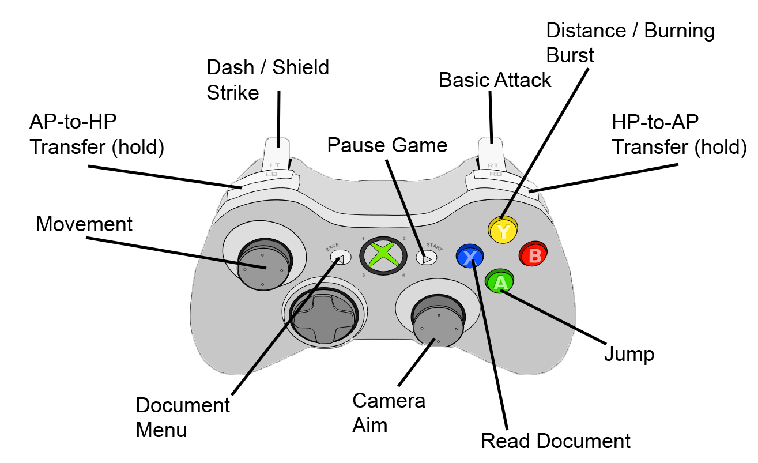

Remote Detonation

Interface:
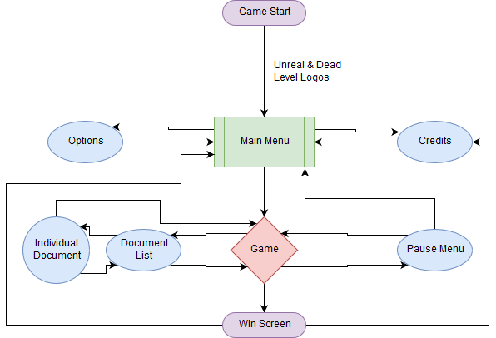
Menu Flowchart:

HUD:
In-Game:
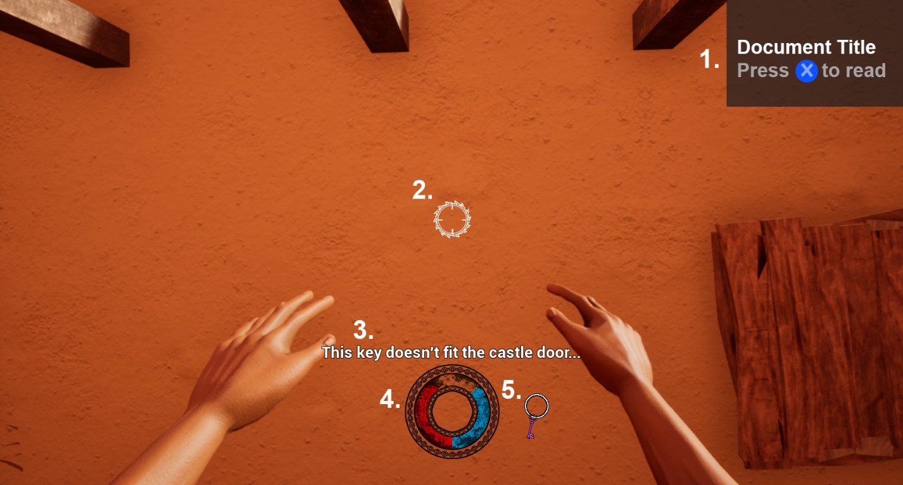
- Document Pop-Up - The pop-up in the upper-right corner appears for 3 seconds once the player picks up a new document and displays the title of the document they have acquired. After that time, the pop up disappears.
- Reticle – A marker in the center of the screen that indicates where player projectiles travel toward.
- Subtitles – Conveyance and Story information that temporarily and dynamically appears to provide context during gameplay.
- HP/AP Radial Meter - This radial meter reflects the amount of HP and AP the player has at any given moment. HP and AP fill the bar equally, meeting at the bottom and top center when both resources have equal value. As the player loses AP or HP, the relevant bar shrinks from the top center towards the bottom center. If the player has more of one resource than another, that resource fills beyond the top center.
- Key Ring – This shows the player how many keys they have collected, and what color the collected keys are.

Document Menu:
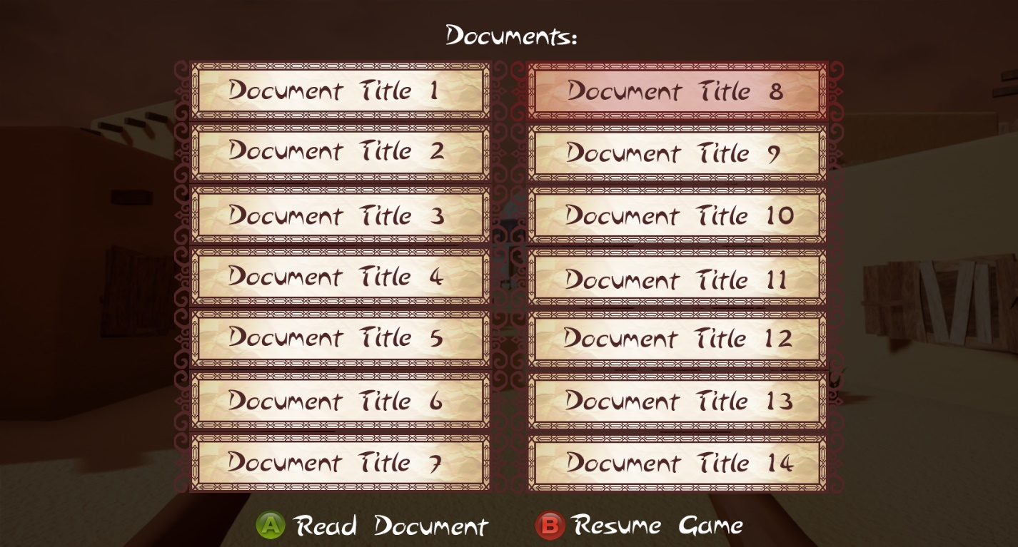
The document menu has two columns that are populated with documents as they are collected. The player’s selection is represented by highlighting the document button in red.

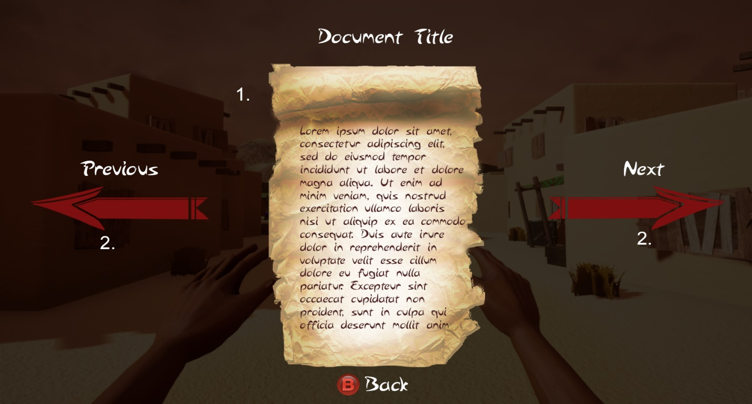
Document UI:

- Document - The middle section contains the title of the document, along with a visual representation and relevant text.
- Arrows - On the left and right side of the screen are two arrows that represent the direction the player must input to switch documents.

Environment:

World Overview:
Gameplay takes place in a variety of areas near the village that the player character had previously ruled. The player begins in dungeon prison cells, with their goal being to escape the dungeon. After escaping the dungeon, they are released into the village. This village has been abandoned and is overrun by demons and golems. Areas of the village include a bazaar and farming district. The player then proceeds into their richly decorated palace. Navigating through their mazelike palace, the player ends in the palace courtyard for the climax of their journey.
Level Breakdown:
Level One
This level introduces the player to their two abilities, as well as the transferring mechanic. After this tutorial, the player explores a vast dungeon and engages in low-difficulty combat scenarios. At the end of the level, the player exits the dungeon, blinded by the outside light.
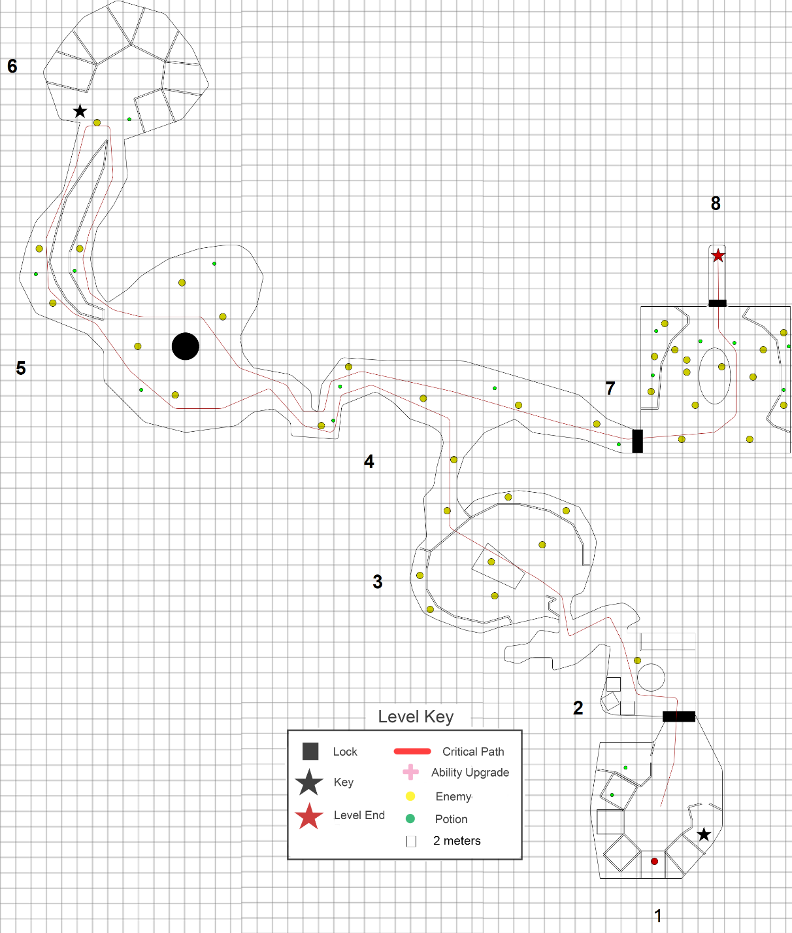
Level Flow - Player spawns in room 1, inside a cell. To the front of them is a locked door, and the key tucked away inside a room to the right. The player uses this key to open the door and access room 2. Inside room 2 is the introduction to the Basic Enemy. Once the Basic Enemy is defeated, the player moves into the corridor and to their right is the entrance to room 3. Inside room 3 the player encounters several Basic Enemies. After defeating these enemies, the player moves to room 4. Room 4 has many Basic Enemies scattered throughout. The player takes a left at the fork in room 4, as the right side has a locked door. The player enters room 5. Room 5 has many Basic Enemies, as well as introducing a single Sniper Enemy. The north end of room 5 connects with room 6, where the player picks up the key to access room 7. The player returns to room 7, unlocking the door and encountering many Basic Enemies and two Snipers. In the center of room 7 is the final key that the player must use to get to the end of the level.

Level Two
This level contains more difficult combat scenarios and varied exploration than before. The first section is a bazaar located at the town square. There is a castle at the town square with a locked door that the player must proceed through to progress to the next level. From there, the player heads to a farm section, where they fight enemies to obtain the key needed to unlock the castle door. The player heads back to the castle and moves onwards to level 3.
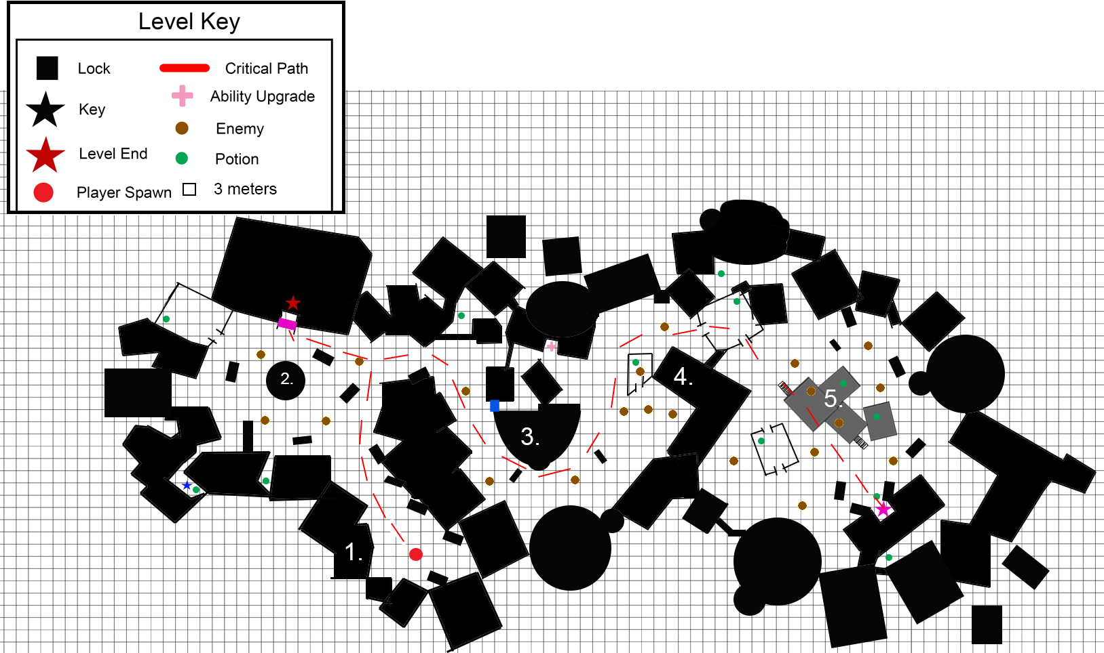
Level Flow - The player spawns in area 1 and heads towards area 2. The player is introduced to the Sniper enemy in this area and fights a combination of Snipers and Basic Enemies. The player moves onto area 3 where they fight a couple Basic Enemies and a Sniper, until they get to area 4. This area has a combination of Basic Enemies, a Snipers. After defeating them, the player moves onwards to area 5. This area has more Snipers than any previous area, with still some Basic Enemies. After dispatching the foes, the player picks up the pink key. From there, the player returns to area 2, unlocks the pink door, and continues with the level.

Level Three
This location is set inside of the castle, with a courtyard as the final area the player encounters. This level puts a focus on combat with usage of verticality. The player’s main goal in this level is to get to the courtyard where Noor is waiting.
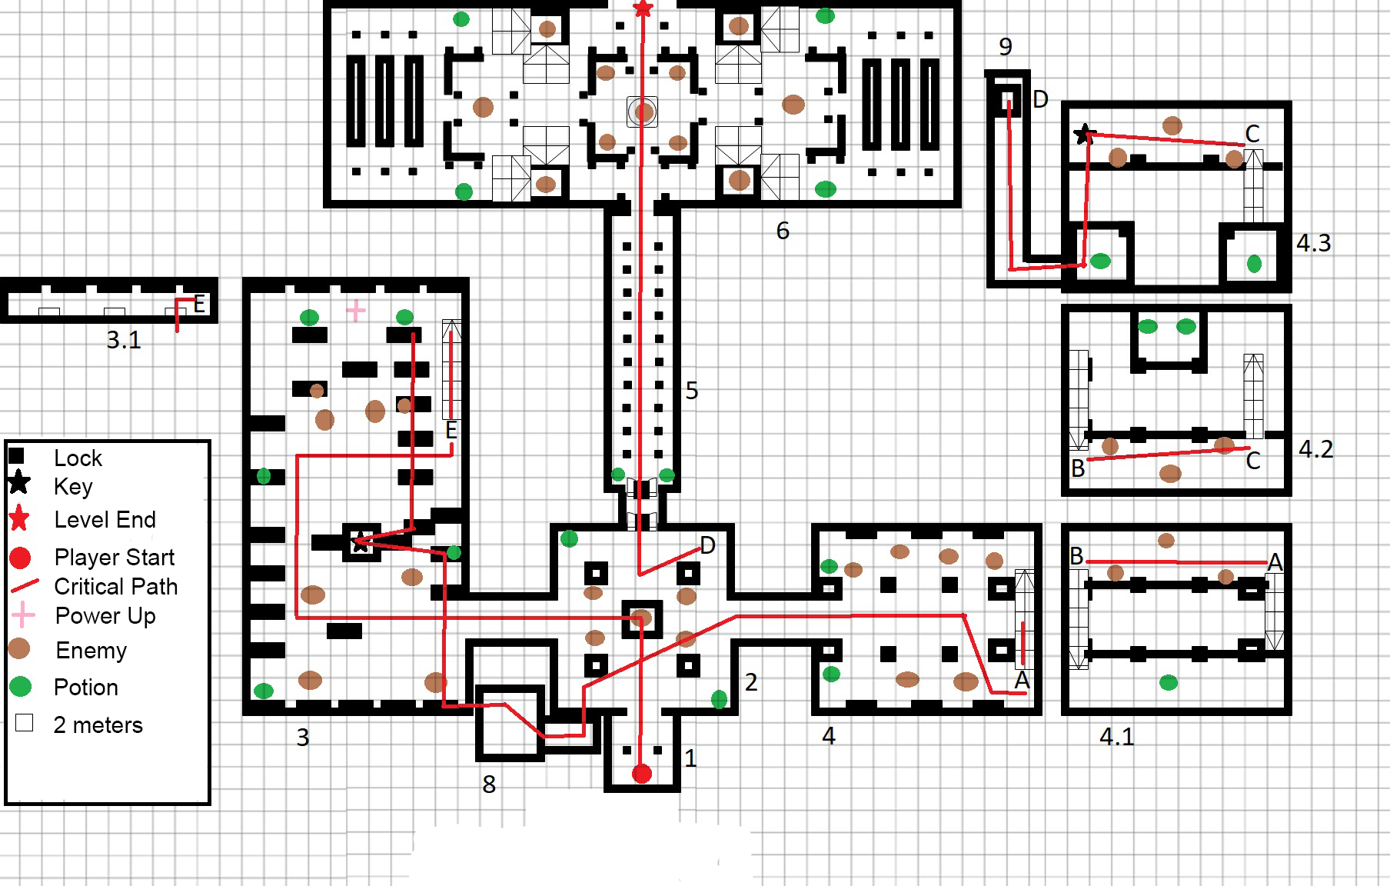
Level Flow - Players spawn in room 1. They proceed forward into room 2 and are confronted by 3 Basic Enemies and one Berserker. To the north of room 2 lie two locked doors. Progressing west to room 3, players are attacked by Basic Enemies on the ground and Snipers on higher elevation. At the far end of the library players climb stairway E to a higher floor from which they platform or dash atop the bookshelves to get a key. From here, the player finds a hidden path to room 8, a secret area that leads back to an otherwise unreachable section of room 2. Back in room 2 the key opens the first set of doors, but behind it lie another set. Heading east to room 4, the player is assaulted by Basic Enemies and a Berserker on the ground and Snipers on the floor above. As the player climbs stairway A to section 4.1, more enemies spawn above. Climbing stairway B, the player reaches section 4.2, and more enemies spawn above. Using Stairway C the player enters section 4.3, the highest point of the tower. At the end of this section is another key. The player dashes across the gap, heading to hidden room 9 and using drop D to return to room 2. With the final key, the player unlocks the last door and heads through room 5 into room 6. The player must defeat the enemies of all types that spawn here. Once all enemies are defeated, the player climbs the steps to the north, ending the game.

